# University of Technology, Jamaica

Faculty of Engineering and Computing

School of Computing and Information Technology



Academic Year 2020-2021

Semester:1

Module: Web Systems Design and Implementation

Title of Paper:**Final Web Systems Group Assessment**

Date of Submission: December 04,2020

Names:

Daniel Reid:1700101

Erick Gentles:1602971

Marc Gordon:1501206

Michael Levy: 1708147

Lecturer: Mr. Lushane Jones

Tuesday Day/Time:Thursday, 8:00 a.m. - 10:00 a.m.

**Group Member Roles**

|  |  |
| --- | --- |
| **Name** | **Roles** |
| Daniel Reid | UML Diagram,Nurse, Documentation |
| Marc Gordon | Admin,Base site and BMI Calculator, Documentation |
| Erick Gentles | Nurse |
| Michael Levy | Documentation |

**Website Disclaimers**

1. The website created does not make use of the internet as it was created for personal use and ran on a localhost.
2. Any content displayed on the website may be inaccurate and user discretion is advised.
3. The website has not undergone intensive testing and consequently may contain bugs.
4. In order to make proper use of the website the user must be logged in.
5. For some animations and styles active internet connection may be needed as the fonts are referenced online from google fonts.
6. The website is very vulnerable to sql injection attacks as the password was neither salted nor hashed.
7. The system needs to be logged in either as a nurse, admin or doctor.
8. Inorder to log in the database must be viewed to see what the current password and username is unless added by the admin.

**Website Development Report**

As students who are learning the importance of working together it was imperative that we tried to understand everyone’s personal style of doing things. As this was a project revolving coding this made things a little more challenging. While great minds think alike everyone codes differently. This was the first barrier that had to be overcome so that progress could be made. While each of us may think our personal way might be the best at doing a particular task, when someone makes a suggestion the way things were viewed changed for the better. This allows for roundaboutness to be curbed promptly while allowing progress to speed up.

One of the main difficulties faced is the use of the CSS in different form elements. Specifically speaking the BMI Calculator as the calculations were done using the Javascript language. While using the <form> tag the answer for the calculation was being refreshed, so instead it had to be replaced with the <div> tag and from there another class was created to have a similar style as the form, that then allowed the information to stay on the screen without being refreshed automatically due to the CSS coding.

Passwords are very secretive texts which should be protected at all costs. As such measures were taken to try and reduce the exposure of passwords in the database. Salting and hashing methods of security were explored but seemed to prove difficult. The decision was made to abandon this area and try to aim the focus on the more essential parts which were explicitly stated.

Collaboration on a single item seemed to prove difficult as we were unable to readily make changes to what could be called a “main document” . We each had to download a version of what one person did then add your part to it. As each person was working on a different computer using different browsers, some pieces of code caused errors to occur when no errors should be generated in actuality.

**Functional & Non Functional Areas of the Website**

|  |  |
| --- | --- |
| **Functional** | **Non Functional** |
| * **Administrator can**    + **manage all user accounts.** |  |
| * **A guest can**   + **view the website**   + **calculate BMI.**   + **Login**   + **make appointment** |  |
| * **A nurse can**    + **view the website**   + **calculate BMI.(check)**   + **make appointments (first and last name, date)**   + **login using staff ID or Email Address and Password**   + **edit patient profile**   + **search a patients’ record using either first or last name.**   + **register and log when a patient comes in for a doctor visit**   + **search for appointments**   + **view appointments**   + **edit appointment status.** |  |
| * **A doctor can**    + **view the website**   + **calculate BMI.(check)**   + **make appointment (first and last name, date)**   + **login using staff ID or Email Address and Password**   + **edit patient profile**   + **search a patients’ record using either first or last name.**   + **register and log when a patient comes in for a doctor visit**   + **search for appointments**   + **view appointments**   + **edit appointment status.**   + **add reason for visits to each patient on the day of visit.** |  |
|  |  |

**UML DIAGRAM IN REPRESENTATION OF THE WEBSITE**

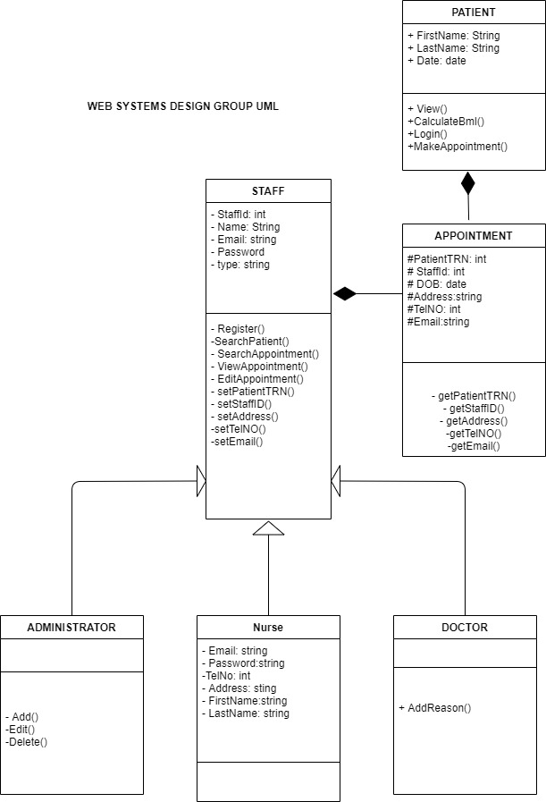

It can be seen that a staff member can be one of three roles: an administrator, nurse or a doctor. Nurses, doctors and patients are able to make appointments.

**Learning Experiences of the Team**

**General Team View:**

The group has grown extensively from the many attempts we have made at completing the project. We all realized that hands-on learning is better than reading and just watching videos. By attempting each area of the project,, assigning various roles and executing them we have gradually grown as programmers. The system was not easy to implement. We had to share our knowledge and put in a lot of countless hours of work. Our main challenge was working with the database and managing to be consistent with the css design.. It gave us a lot of errors and also understanding just exactly what the project needed in terms of what the instructions were asking.

**Individual View:**

**Daniel Reid:** I personally grow as a developer through doing my part in contributing to the project. By first making the UML diagram and trying my best to pull the team's effort into one it was fun and stressful. However it was really worth it. The project taught me how to be timely and intentional. It taught me how to work collaboratively which i think will come in handy for the future working on other projects. It also taught me how to analyze code that has not been written by me and make sense of it and debug it where necessary.

**Erick Gentles:** This course was engaging and flowed well. All topics were related to each other and I grew as a developer.

**Marc Gordon:** As a developer learning PHP came in handing. I learned alot about what I didn't know prior to this project and module. Sessions & validation were my focus areas that I needed to develop.

**Michael Levy:**

**Commentary on Module Offered**

**Commentary of Module offered (classroom, lab, lecturer, delivery, etc)**

The module offered was one that was interesting. Many different things were taught which could be added to the different arsenal of website building techniques that we were taught. The content was not overwhelming but it was easy to follow,replicate and understand.The lecturer presented the content in an interesting way and always allowed welcomed students to give feedback on any line of code,section or topic that was not fully understood. Everything was explained in a step-by-step manner which allowed for easy understanding. The lecturer was always punctual and understanding and treated and was treated with respect by his students. The module was practical which came in handy for learning outside of class. Enough time was given to not only complete assignments but to study, practice and actually understand what we were doing rather than rushing through with other subjects. In general this course should be an example to other modules and lecturers of Utech to take a lesson from. The team has successfully learnt a lot about: HTML, CSS,PHP,Validation, Sessions, Cookies and much more.